Manav Rachna Educational Institutions
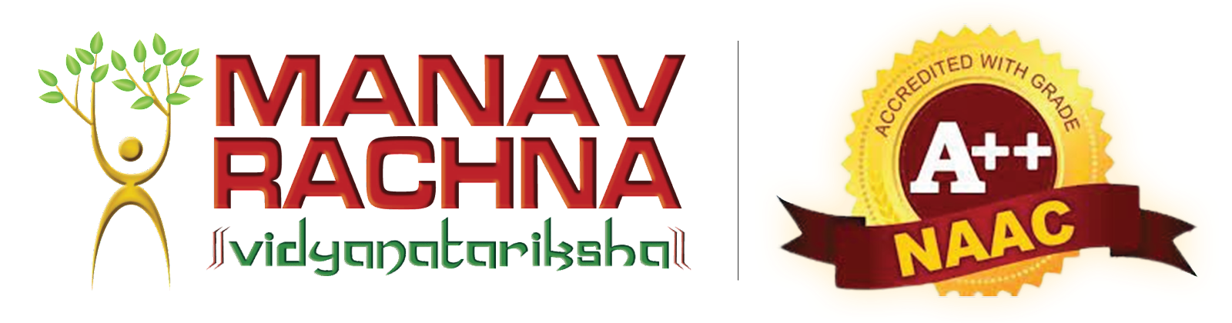

Academic Session 2023-24

Job Description
OVERVIEW
Name of the Department/ Campus Unit | Corporate Resource Centre, MREI
Name of the Mentor | Ms. Shalini Khatri
Website / Other source of Information | https://manavrachna.edu.in/corporate-resource-center/
Profile Type | Non - Teaching Profile
Brief write-up on the Department | The major focus of the CRC is to enhance the placement opportunities for the final year students of all streams. CRC also assists Faculties/ Departments in seeking summer training/internship slots for the students with various industries. This is being achieved by forging an alliance between the academia and the Industry. Needless to state, for improving the employment quotient of students, it is important to develop their technical, managerial and soft skills in tune with the corporate needs. This task is being undertaken by an accomplished pool of faculty in the University. For soft skills training, the faculty has also been outsourced from accomplished National Level trainers.
JOB PROFILE
Designation | Placement Coordinator Intern
Job Description | Responsibilities and Duties:  - Acts as an interface between the Faculty Placement Coordinator and the students of the appointed course.  - The very first set of students to learn about the companies coming down to the campus/ hiring from the campus  - Passing the company's information to the students. Connecting with Industries and their fellow colleagues from the other campuses.  - Resolving the queries of the students if any and reporting it to the placement department.  - Motivating students to participate in the drive.  - Informing the department for any new development happening or if any changes is to be done in terms of extending job opportunities.  - Should abide by the privacy norms and should avoid leaking any confidential information.
Skills Required | Skills Required:  - Good Communication Skills  - Sound knowledge of Ms Office preferably Ms Excel and PPT.  - Should have a good reputation among students of his/her respective field..
Place of Posting | A Block CRC Dept.
Duration of Internship | 6 Months (Start/End Date & Time to be decided by the department)
No of Interns | 2
SALARY DETAILS
Maximum No. Of Hours | 40 hours per month
Training Period | 5 Hours
Stipend paid during training | Rs. 100/- Per Hour
Bond or Service Contact (If yes, give details) | Yes (in form of joining letter)
ELIGIBILITY
Eligible Courses/Branches | UG/PG
______________
MR IMPACT

